CREATE JAVA APPLICATION

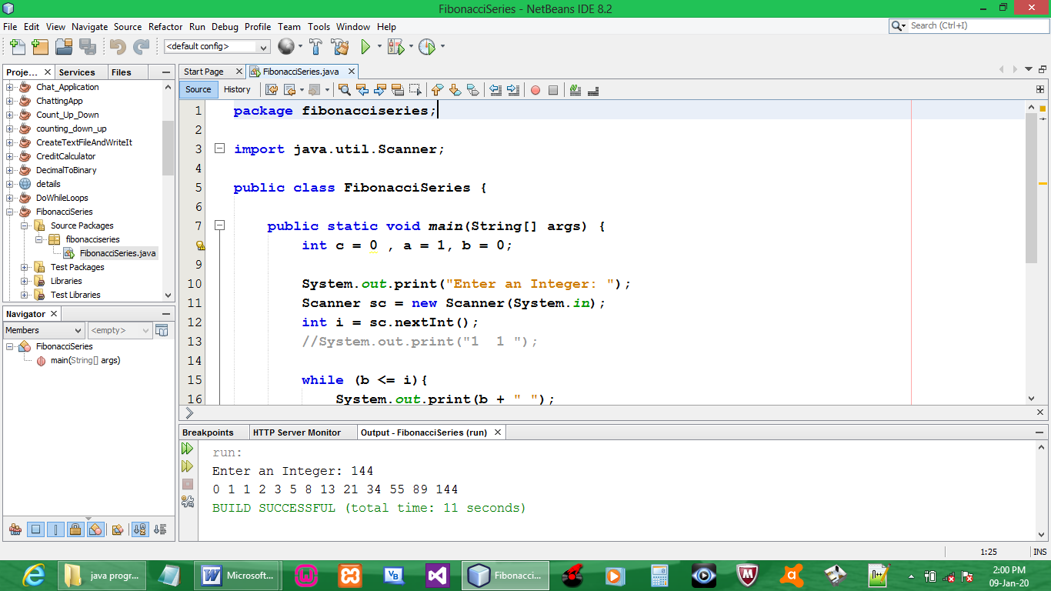

CODE:

package fibonacciseries;

import java.util.Scanner;

public class FibonacciSeries {

public static void main(String[] args) {
int c = 0 , a = 1, b = 0;

System.out.print("Enter an Integer: ");
Scanner sc = new Scanner(System.in);
int i = sc.nextInt();

while (b <= i){
System.out.print(b + " ");
c = a + b;
a = b;
b = c;
}
System.out.print("\n");
}
}

OUTPUT:

